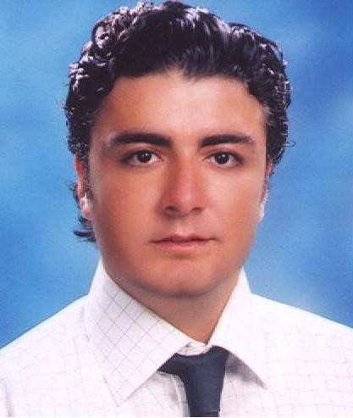

Nevzat FİLİZ
• Yeşil Kıbrıs Sok. Semiz Apt. No:1 Kat:4 D:9 4.Levent / Istanbul
• 542-325 2516 • 505-561 3086 • e-mail: newzatfiliz@engineer.com

P E R S O N A L

Birthday, Place : 26.10.1978, Konya

Gender : Male

Marital Status : Single
Driving License : Class B

Military Service : Completed

O B J E C T I V E

As a newly graduate candidate, seeeking an entry level engineering position in Information Technology or Electronical Communication field.

E D U C A T I O N

1997-2002 Electronics Engineering

The University of Istanbul, Istanbul

Transcript Degree: 2,72 (4)

Education Language is English
Senior Research Project: Wireless Lans

1993-1997 Department of Science & Mathematics
Ereğli Super High School, Istanbul
Education Degree: 4,18 (5)

Education Language is Turkish

C O U R S E S A N D C E R T İ F İ C A T E S

2003-2004 English Course, English Time Language School (6 months)
Successfully Completed Upper-Intermediate Level Program,
Attending to Advanced Level Program

  - ODTÜ İDEA BTSP, Attending Information Technologies Certificate
Program at Middle East Technical University. (9 months) Courses:

1. Computer Systems and Structures 5. Software Engineering
2. Computer Programming with C 6. Database Management Systems
3. Data Structures and Algorithms 7. Web Programming
4. Operating Systems with Unix 8. Software Development Project

1997-1998 University English Preparation Class, The University of Istanbul (1 year)

1993-1994 Hıgh School English Preparation Class, Ereğli Super Hıgh School (1 year)

S Y S T E M S K N O W L E D G E A N D P R O F I C I E N C Y

Operating Systems Applications Programming Language
Windows Family Macromedia Dreamweawer C
DOS Frontpage Turbo Pascal
Unix (Basic Knowledge) Excel Html
PowerPoint Sql (New)
Outlook
Word

W O R K E X P E R I E N C E

2003-2004 Project Officer,

(8 months) Jandarma Mebs.(Comunication and Electronical Information
Systems) İşl. Ve Des. Grp. Kom.

Technical support on PC Systems, Windows, MS Exchange,

MS Outlook and MS Office Programs, Preparation of Projects Taken 2 Letters of Appreciation for Hard-working Studies

2002-2003 Electronics Engineer
(6 months) Uluer Tekstil A.Ş. (İstanbul)
Installation, Troubleshooting and Maintenance of
Electronical Machines

Summer, 2001 Summer Trainee
( 2 months) Aselsan (İstanbul)
GSM, Radio Systems, OGS

S K I L L S A N D A B I L I T I E S

Languages: Advanced English

Interests: Reading PC Magazines, New Technologies, Basketball and Swimming.

R E F E R E N C E S

Available upon request.

